Homework 4 PCA
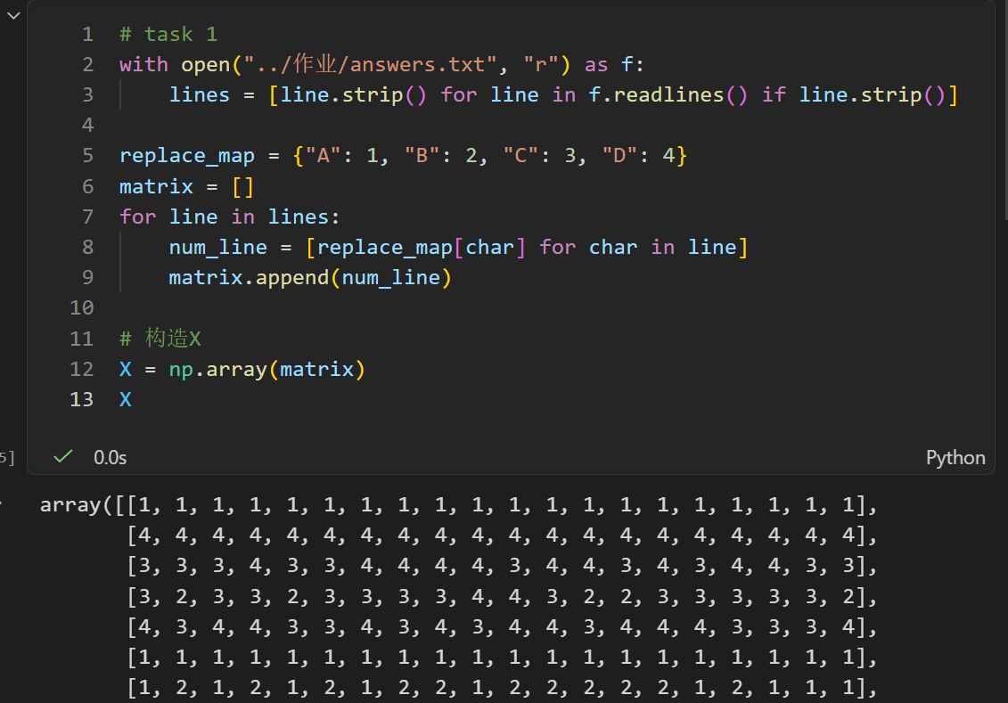
Task 1: Read answers.txt and convert the letters back into numerical values {1, 2, 3, 4}
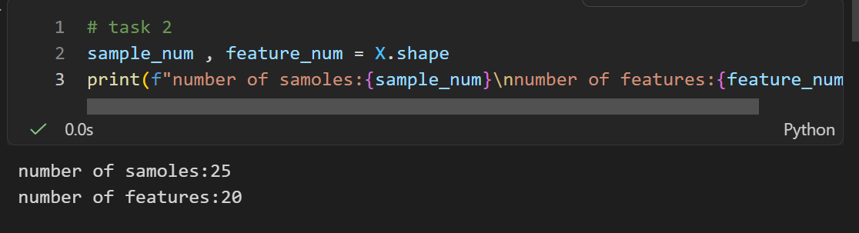
Task 2: Determine the dimensions of the data matrix from the text file
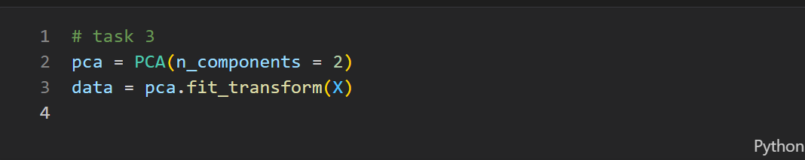
Task 3: Apply PCA to the numerical matrix and keep only the first 2 principal components
Task 4: Reconstruct the original data matrix from the PCA representation. 
Task 5: Round the reconstructed entries to the nearest value in {1, 2, 3, 4}, and clip values if necessary so that all reconstructed entries stay within this range
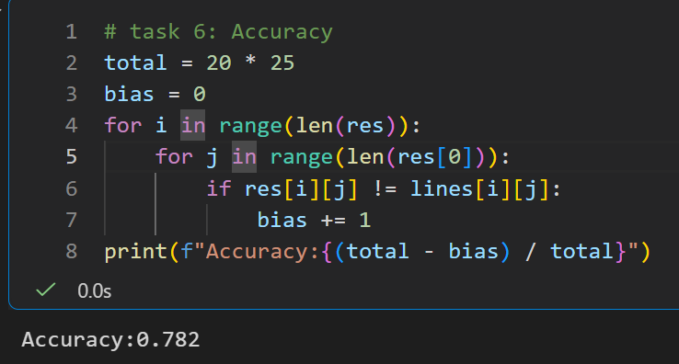
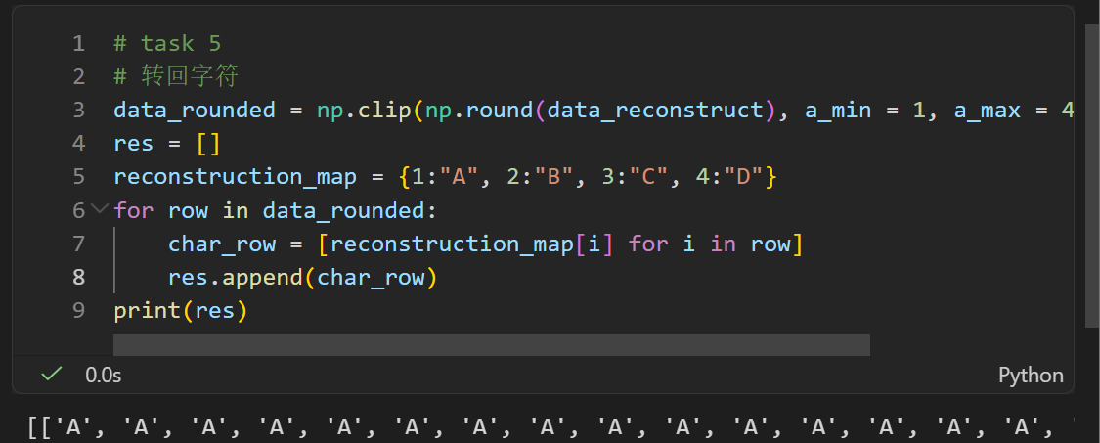
Task 6: Compute the reconstruction accuracy:
Task 7: Compare the storage requirement of the original data with the storage requirement of the PCA representation.
